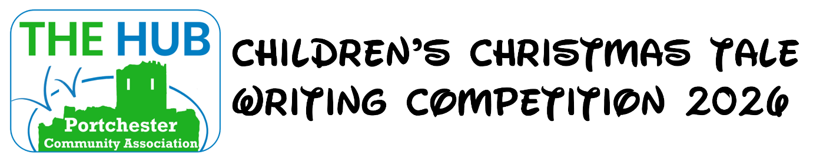

Childs Name
Age
School Name
School Year
Parent/Guardians Name
Contact Number
Email Address
Home Address
Your Stories Title

- Your story can be a maximum of 500 words
- You can type your story on the next page of this form
- You can either email your story direct to The Hub
  - Email address: admin@portchesterhub.com
  - Subject: Children’s Christmas Tale Writing Competition 2026
  - Attach your saved story to the email
- You can also print off your story and drop it into The Hub

